**Experiment -10**

Write a PL/ SQL program for calculating the factorial of a given number.

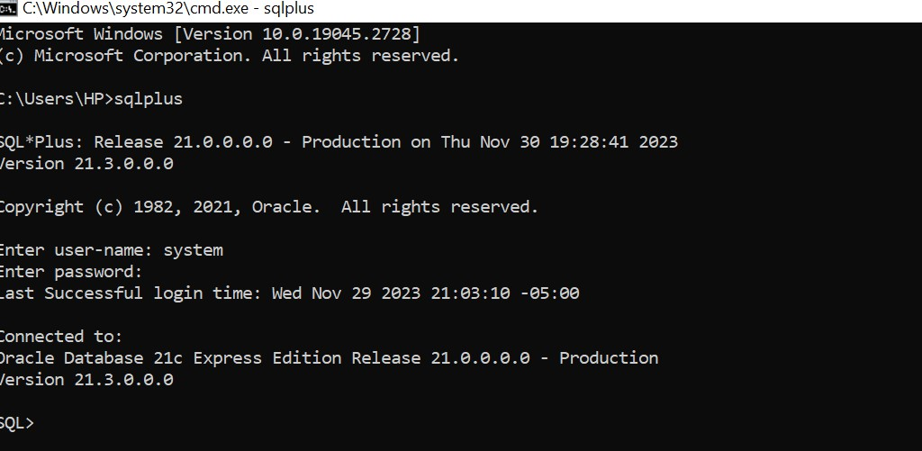

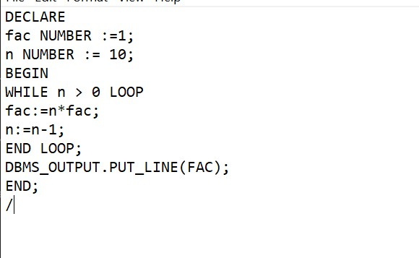

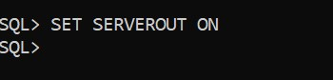

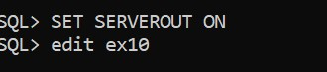

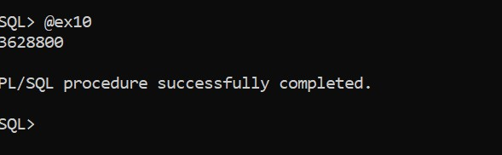

**Experiment -11**

Write a PL/SQL program for finding the given number is prime number or not.

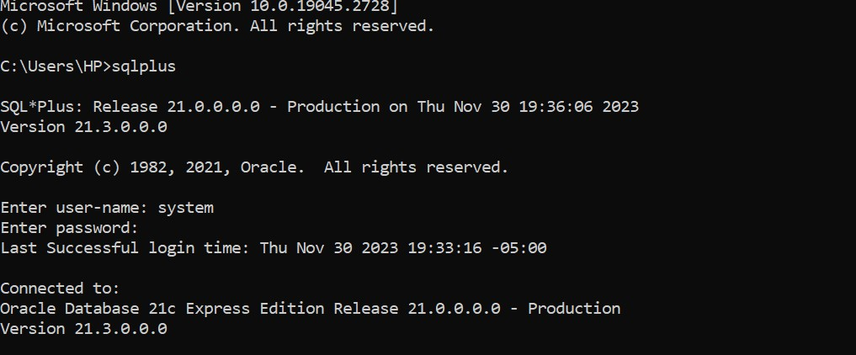

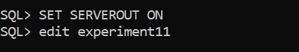

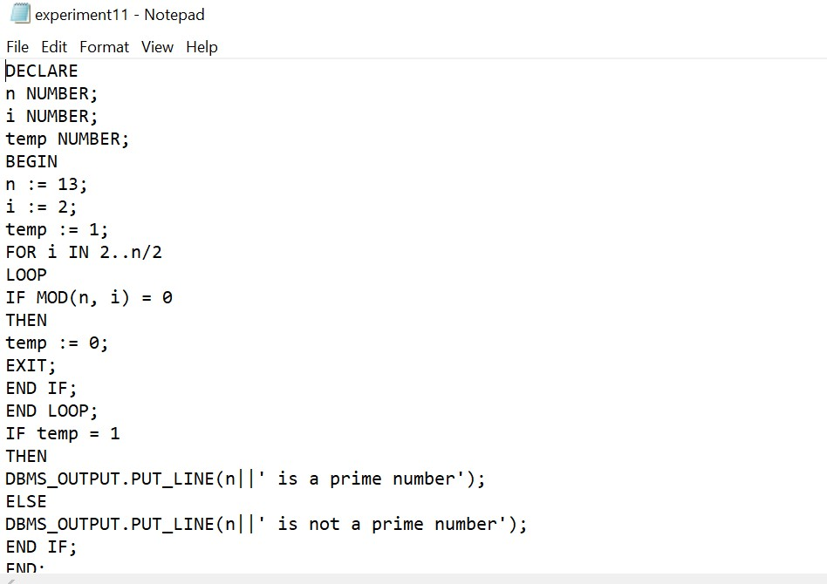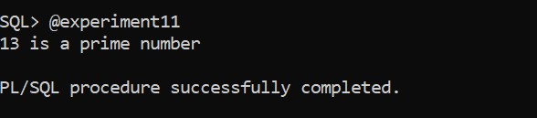

**Experiment -12**

Write a PL/SQL program for displaying the Fibonacci series up to an integer.

